**1)Java installation**

* Install JDK 1.8.0_161 and JRE 1.8.0_161
* Change in Environment Variables -> User Variables -> New…
* Set path in System Variables.

Application

Install jdk-8u161 setup

For Detailed Installation Guide move to

\\sw80fps01\FileShare\IT\Tools\Documentationwithtools\1_jdk8_configuration\JDK 8

Create environment variable

Press Windows + R keys together, type the command “sysdm. cpl” go to advanced tab

click Environment variables, add variable given in screen shot

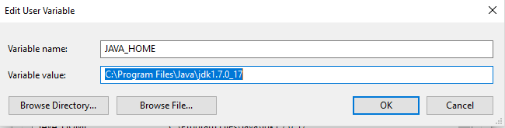

Also Add in path

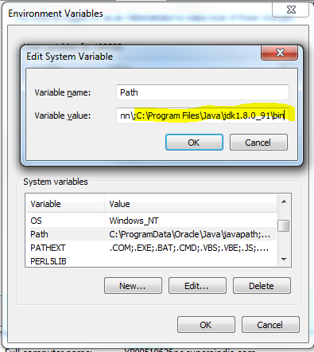

Flowing steps for without restart system

1) open cmd admin

2)type set PATH=C

3)close cmd restart

4)type echo %path%

**2) Install source tree application and then**

**Create a new folder in C: drive name “pmt” and inside it a folder named “bit” and inside it 2 folders named “erpStatic” and “SpineIT-ERP”.**

* Clone the files from Bit Bucket and Source Tree after you got the access to all files

<https://bitbucket.org/erpglobus/erpsource/src/master/>

Click on Clone in SourceTree.

* In Sourcetree make sure you browse the SpineIT-ERP and the Clone it.

Check this files are available in your C:\pmt\bit\SpineIT-ERP, mainly app, com, Database, Databasewarehouse, erpglobus, htdocs, www, backup files are not required

Now repeat the same process for ERPStatic folder from your Repository

<https://bitbucket.org/erpglobus/erpstatic/src/master/>

**3)copy Apche2.4 from documentwithtools**

**open cmd in file C:\Apache24\bin**

httpd.exe -k install

**open ApacheMonitor application in bin**

* It has CONF folder.IN this conf check these files are available or not
* httpd,
* mod-jk ,
* worker-properties
* In workers.properties file change your system name like localhost

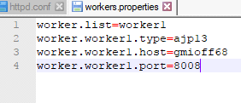

* In httpd file change your pmt path like C :/pmt/bit/SpineIT-ERP/htdocs"

Change your path according to the SpineIT-ERP folder and add htdocs to the end,

* In httpd file check this last line is include or not

**#BEGIN PHP INSTALLER EDITS - REMOVE ONLY ON UNINSTALL**

**PHPIniDir "C:/PHP8/"**

**LoadModule php8_module "C:/PHP8/php8apache2_4.dll"**

**AddType application/x-httpd-php .php .php3 .phps**

**#END PHP INSTALLER EDITS - REMOVE ONLY ON UNINSTALL**

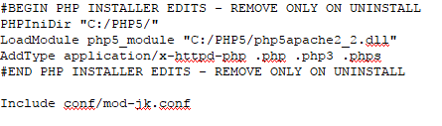

* In Apache2.4 -> module folder -> check mod-jk and mod-wl-22 available or not
* Run your apache monitor in bin folder

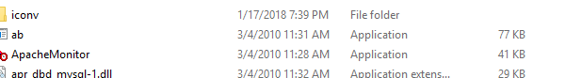

**4)Apache-Ant-1.0.1**

* Install apache ant in c drive

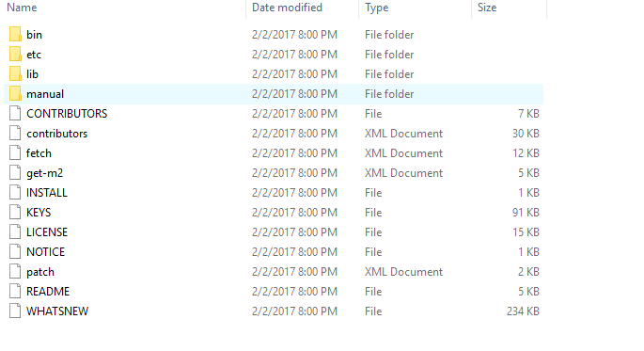

* And the copy the files from

\\sw80fps01\FileShare\IT\Tools\Documentationwithtools\4_ant_configuration\AntConfiguration\Build.xml prerequisite

to your C:/pmt/bit/

**5) Jboss-eap-7.0**

* Copy Jboss in c folder from \\sw80fps01\FileShare\IT\Tools\Documentationwithtools\5_jboss_eap_7.3_configuration\JbossConfiguration.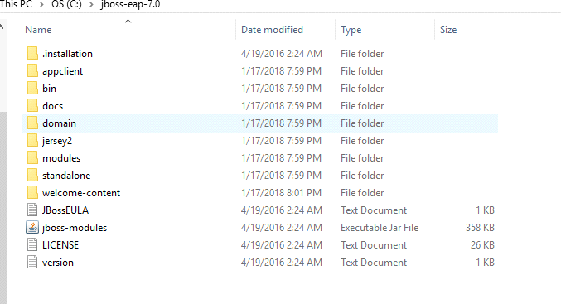

In standalone folder->configuration folder

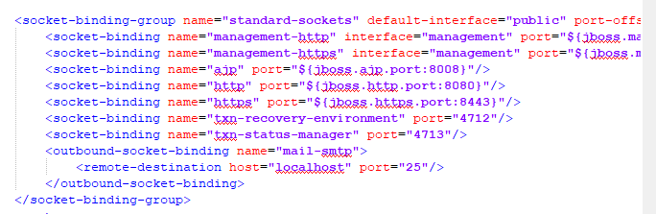Check your port no to be 8080 in Standalone file

* Check standalone-full file for HOST_URL and change it to localhost and sam as HOST NAME

* Change and save file

**6)PHP 8**

Get your PHP8 from here: <https://www.php.net/downloads.php> Check this files are available in your php8

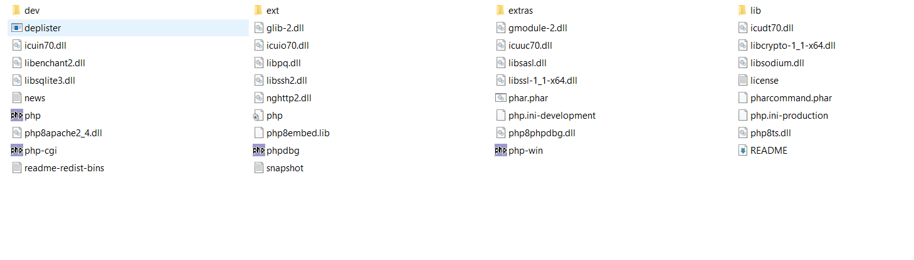

**8 ) ECLIPSE 4.15 CONFIGURATION**

If you are new to Eclipse then first take the udemy course for prerequisite knowledge.

[Eclipse Tutorial For Beginners : Learn Java IDE in 10 Steps (udemy.com)](https://globusmedical.udemy.com/course/eclipse-java-tutorial-for-beginners/learn/lecture/4358070?learning_path_id=1283518#overview)

* Add files in eclipse
* Click File>New>Others
* select java project option and then click next and uncheck use default location browse Dir
* add files app,com,Database,htdocs,www

* Create external configurations

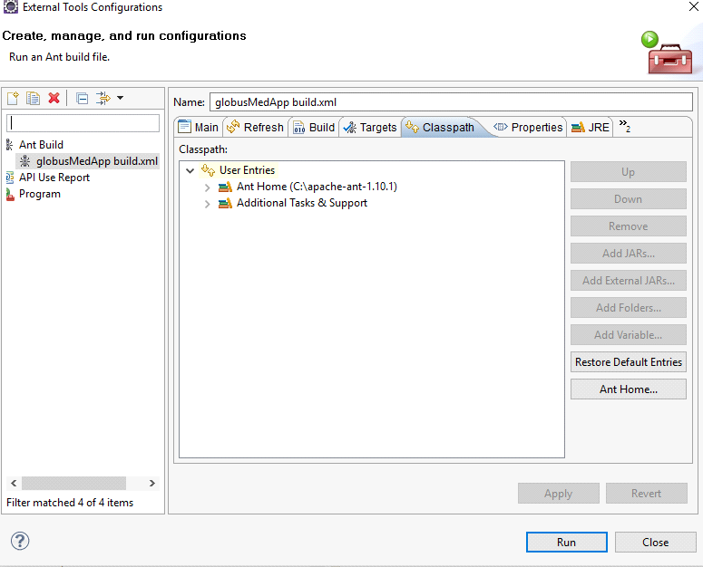Check your classpath, JRE, Common

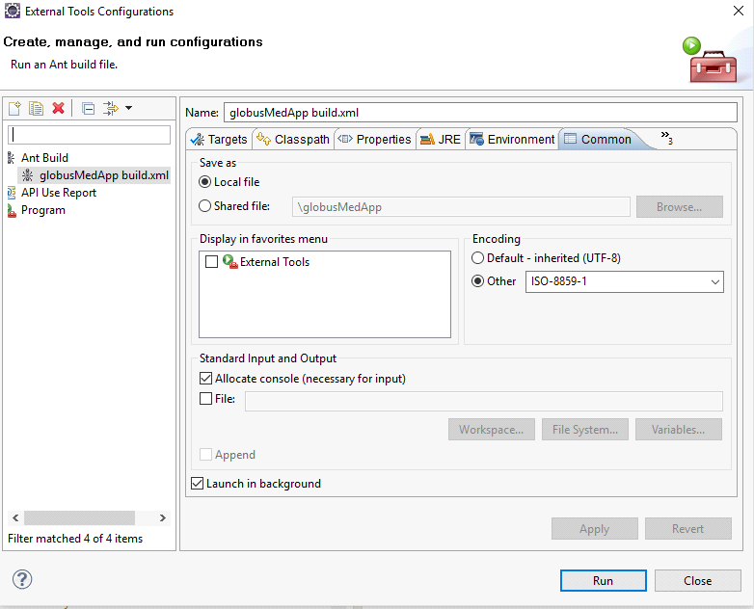

Not go to Eclipse -> Window -> Show View -> Ant

In Ant Tab right click and choose “Add butterflies” -> app -> build.xml

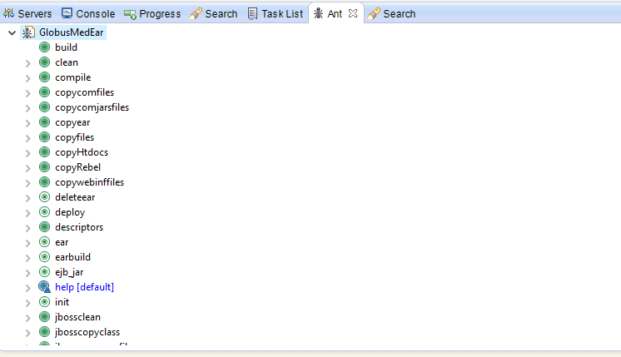In the Ant tab-> GlobusMedEar

**Click**

**1st** CLEAN then  
2nd BUILD then  
3rd EAR

Check ear file generated or not in jboss->standalone->deployments

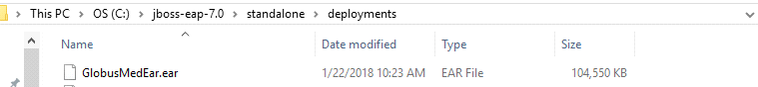

6.3)create Jboss server

In server->create new

Choose create new runtime(nextpage)🡪Click Next

Check jre and standlone-full is correct in respective jboss directory

Once create start the server. if successfully running check this scenario

1)Deployed file is created in standalone folder

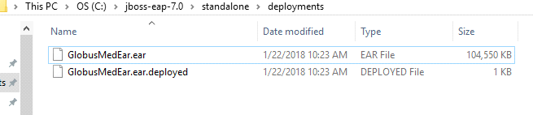

2)Check all property files loaded in explorer

[gmioff69/GmCommonInitServlet](http://gmioff69/GmCommonInitServlet) if this doesn’t work try this [localhost/GmCommonInitServlet](http://localhost/GmCommonInitServlet)

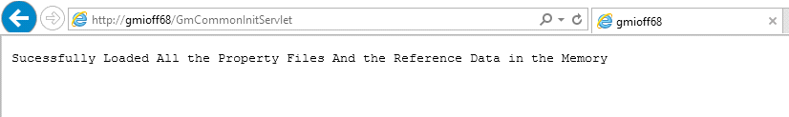

3)check spineIt login is working

[GlobusOne Enterprise Portal (US)](http://localhost/GmLogin.jsp) or gmoioff69/GmLogin.jsp

All the Best.